CONSTRUCTION OF GAS DETECTOR

Akshay Srivastava (Department of Chemical Engineering, Manipal University Jaipur)

Motivation of the project:

In a developing country such as ours, toxic gas emission is becoming an impending problem. Signs of this problem can already be observed by the accelerating rate of air pollution in metropolitan and industrial cities of India. As per a study based on 2016 data, at least 140 million people in India breathe air that is 10 times or more over the WHO safe limit **[1]**. *Indpedia* reported a survey in March of 2019 that categorized different sources of air pollution based on the magnitude of their contribution.

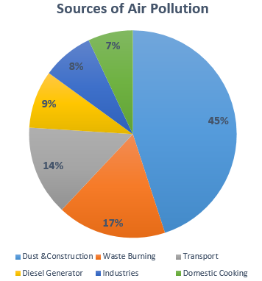

Fig. 1: Sources of Air pollution.

Though the Government of India has started taking initiatives in mitigating this problem, automated and inexpensive detection of these emission gases is yet unachieved. *Times of India* reported that out of 5000 cities with recorded emissions, only 300 are monitored either automatically or manually. Furthermore, according to data published by *TOI* in 2018, presence of major pollutants such as Carbon Monoxide, PM 2.5/10 and SOx/NOx is only increasing with time. Since these pollutants are not adequately monitored in the nation currently, planning ahead to reduce the emissions and consequently isolation of these from air is also not effective. This proposal hence focuses on the design of an effective yet inexpensive Infra-red gas analyser for continuous and autonomous inspection.

Working Principle:

Infrared Gas Analyser:

The infrared gas analyser shall working on the basic principle of a PUC analyser that measures the trace gases by determining the [absorption](https://en.m.wikipedia.org/wiki/Absorption_(electromagnetic_radiation)) of an emitted [infrared](https://en.m.wikipedia.org/wiki/Infrared) light source through a certain [air](https://en.m.wikipedia.org/wiki/Air) sample. Trace gases found in the Earth's atmosphere get excited under specific [wavelengths](https://en.m.wikipedia.org/wiki/Wavelengths) found in the infrared range. The concept behind the technology can be understood as testing how much of the light is absorbed by the air. Different molecules in the air absorb different frequencies of light. Air with lots of a certain gas will absorb more of a certain frequency, allowing the sensor to report a high concentration of the corresponding molecule. The device functions on the principle of IR spectroscopy and since the detection of the gas is characteristic, the problem of cross detection of different species is nullified.

Though this concept is already available for continuous inspection in the form of a PUC analyser, the device is not meant for the detection at high temperatures. The recommended operating temperature for this sensor is ~55oC. This is because the semiconductor components used to make the device begin to malfunction at temperature above their given operating range (a range of ~-40 to 85°C). Hence in order to operate the device at such high temperature it is necessary to either (i). Cool the in-flowing sample or (ii). Isolate the system from the sample analysis chamber and insulate the system with an effective insulator. Cooling the in-flowing sample is eliminated as an option since it adds (i). operational costs to the sensor and (ii). Increases the chances of malfunction. Hence the basic concept of this analyser shall revolve around coating the in-flow sample chamber in a sleeve of Aerogel.

Aerogel is a [synthetic](https://en.wikipedia.org/wiki/Manufacturing) porous [ultralight material](https://en.wikipedia.org/wiki/Ultralight_material) derived from a [gel](https://en.wikipedia.org/wiki/Gel), in which the [liquid](https://en.wikipedia.org/wiki/Liquid) component for the gel has been replaced with a [gas](https://en.wikipedia.org/wiki/Gas).[[4]](https://en.wikipedia.org/wiki/Aerogel#cite_note-goldbook007-4) The result is a solid with extremely low [density](https://en.wikipedia.org/wiki/Density)[[5]](https://en.wikipedia.org/wiki/Aerogel#cite_note-GuinnessRecord-5) and extremely low [thermal conductivity](https://en.wikipedia.org/wiki/Thermal_conductivity). Aerogels are produced by extracting the liquid component of a gel through [supercritical drying](https://en.wikipedia.org/wiki/Supercritical_drying). This allows the liquid to be slowly dried off without causing the solid matrix in the gel to collapse from [capillary action](https://en.wikipedia.org/wiki/Capillary_action), as would happen with conventional [evaporation](https://en.wikipedia.org/wiki/Evaporation).

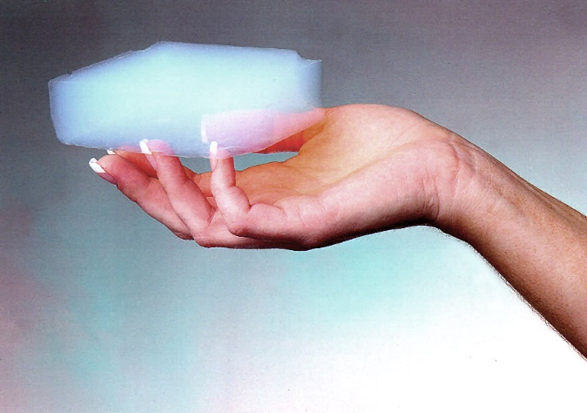

Fig 2: Block of Aerogel.

Thus this project may be divided into the following different parts. These are:

* Making an IR spectrometer to function as a gas analyser with an isolated sample chamber made out of thick quartz glass.
* Calibration of the analyser using gas samples.

IR Spectrometer:

The spectrometer shall use a source of IR that is irradiated onto an IR camera through a sample casing made out of quartz channel. The signal that is captured shall be processed to check for absorption spectra. Then it would compare the incoming signal against calibration data to calculate the concentration and the chemical composition of sample gases. There are a few limitations that come with this design. These are as follows:

* IR cameras are not meant to detect the intensity of absorption. This means that the degree of accuracy depends highly on the build of the camera.
* Though temperature does not play an important role in IR spectroscopy, the camera may malfunction due to the high temperatures.

The Schematic Diagram of the IR spectrometer is as shown:

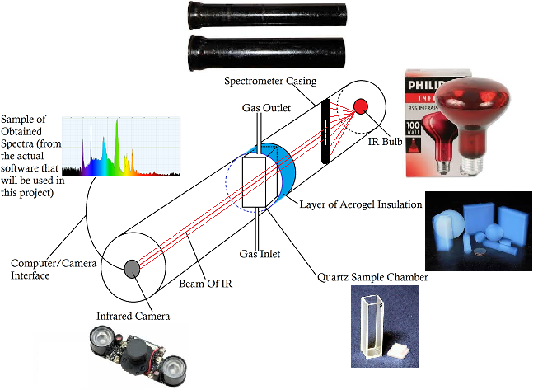

The design is housed in a cast iron tube (which can be coated internally with a matt black paint to avoid any internal reflection of light that may enter the setup though any openings). The ends of the tube are sealed with appropriate sized couplings. A hole is drilled centrally on either sides of the couplings to house the diode on one side of the tube and the camera on the other. Three holes are drilled into the tube. Two in the centre of the tube to allow for the inflow of gas into the quartz cuvette whilst the third hole is drill to create a vacuum in the tube chamber. The inlet and outlet holes are drilled to be larger than the actual size of the inflow channels since they shall be coated with a sheet of Aerogel to allow for appropriate insulation. The tube assembly may also be cooled externally if the temperature of the tube becomes exceedingly hot. A light slit is also placed between the diode and the sample chamber to allow for only coherent rays to pass through. The sample chamber is then aligned with the IR trajectory. The IR camera is then placed in the straight path trajectory of the diode through the coupling. The camera is then connected with a computer and is configured with Thermino for wavelength analysis. Once configured, the apparatus is sealed and a vacuum is maintained to avoid any absorption by air. The setup is then calibrated by using known concentrations of pure gases and the apparatus may then be used for continuous inspection.